Saturday, 19 September 2026, postcard

Avignon: Van Gogh, the Pont du Gard, Châteauneuf du Pape, champagne and oysters, and the Signature Dinner

The choices on Saturday morning were (1) the village of St. Rémy, (2) the Pont du Gard, (3) an on-board lavender workshop. David (who has no interest in lavender sachets) chose the Pont du Gard, because he could hang out in the new museum just opened there and skip the long hike to the "bridge" (actually a Roman aqueduct), which we had visited on a previous trip. Rachel, who is a van Gogh fan (read rabid fanatic) jumped at the St Rémy excursion (which included the asylum where Vincent spent his last months) and I (having no greater interest in lavender sachets than David and never having been there) chose to go with her.

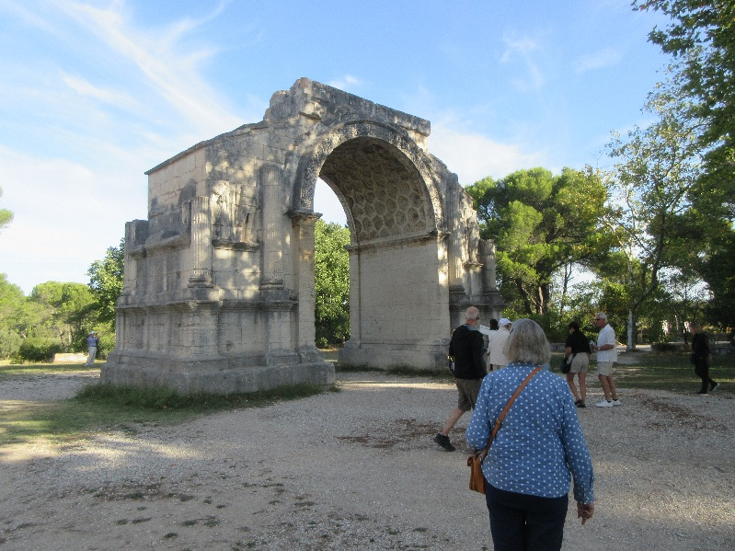
Between the bus parking area and the asylum were two remnants of the Roman settlement of Glanum—they were the two tallest structure in the town and therefore the only two whose tops were still above ground level hundreds of years later. They've since been excavated.

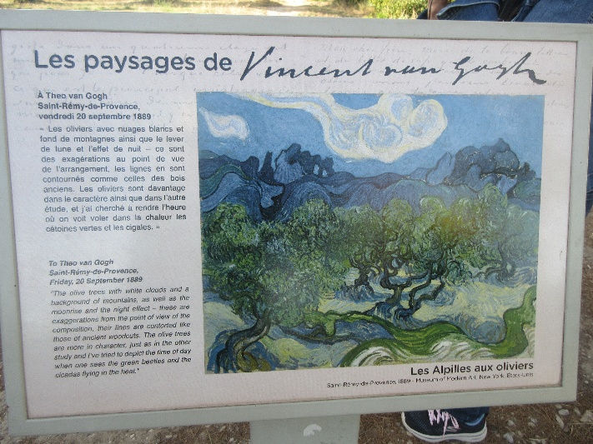
Note the circular medallions lining the underside of this arched doorway—they feature floral motifs portrayed face-on, so I don't know what the folks at Cluny were on about, saying those were an innovation typical of Clunisian architecture.

As we strolled up the long driveway of the asylum, the guide held up this painting (Les Alpilles aux Oliviers), then had us turn and look to our right, where we could, in fact, see this skyline of the Alpilles mountains (complete with the two natural windows in the rock), with olive trees in front.

In the course of the visit, she showed us several other views and vistas made famous in other van Gogh canvases.

"Ordinary" inmates slept in dormitories, many to a room, but Vincent had a three-room suite of his own, all paid for by his brother Theo and one of his sisters.

In the village of St. Rémy itself, we had a guided tour and then time to explore and shop on our own. We were shown the house where Notradamus was born in 1505, as well as the new facade added to the church in the 17th century after (as part of complicated treaty arrangements in the time of Louis XIII) the town was made part of Monaco. Officially, the prince of Monaco is still lord of St. Rémy.

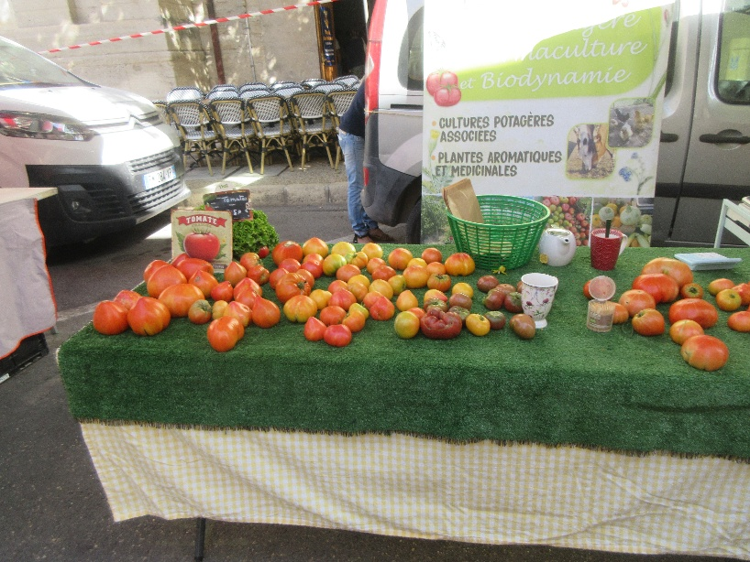
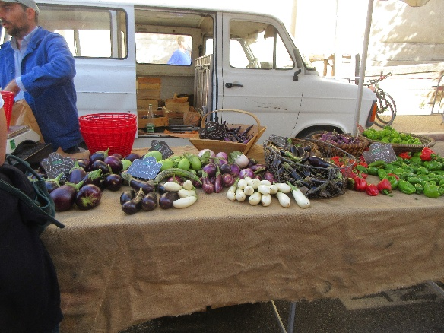
Rachel found perfect gifts for her granddaughters in the shops there. I meanwhile explored the vegetable market. I loved this haphazard assortment of peppers and eggplants.

And this display of tomatoes was pretty ugly, but the merchant had diced one of them to offer samples on toothpicks—and, wow, were they good!

Then back onto the bus for the return trip to the ship. Contrary to my general comment that the food on the ship wasn't very French, lunch featured rillettes of duck! Scrumptious spread on bread.

Then, of course, the main course was barrimundi. Delicious, but back to not very French. Lunch was followed by ice cream in the lounge, several flavors served from two tables, labeled "ice cream social" and "ice cream anti-social."

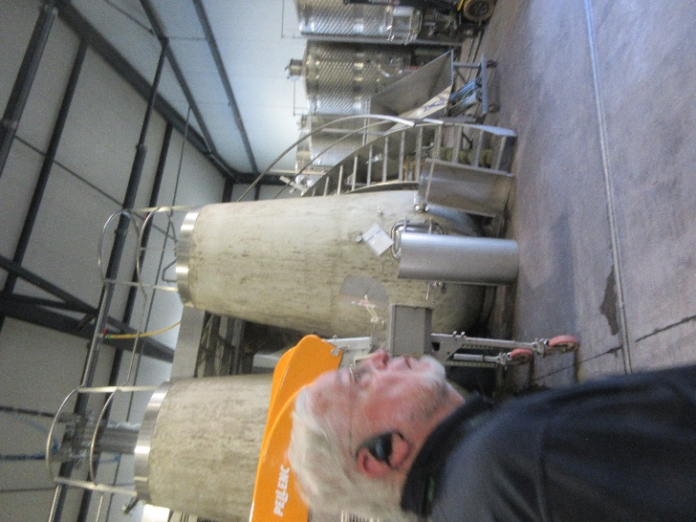
The afternoon excursion was to Château Gigognan, a winery in Châteauneuf du Pape, one of David's very favorite wine regions. They use some French oak barrels, some stainless steel tanks, and in addition, these amazing concrete "tulips," which they claim "breathe" like wood but without imparting undesirable "oaky" flavors.

In general, though, David was disappointed in the wines served in the tasting room—all were served far too young and needed years more in the bottle to be to his taste.

Back to the ship again, for champagne and oysters in the lounge. I skipped the champagne, but the oysters were great.

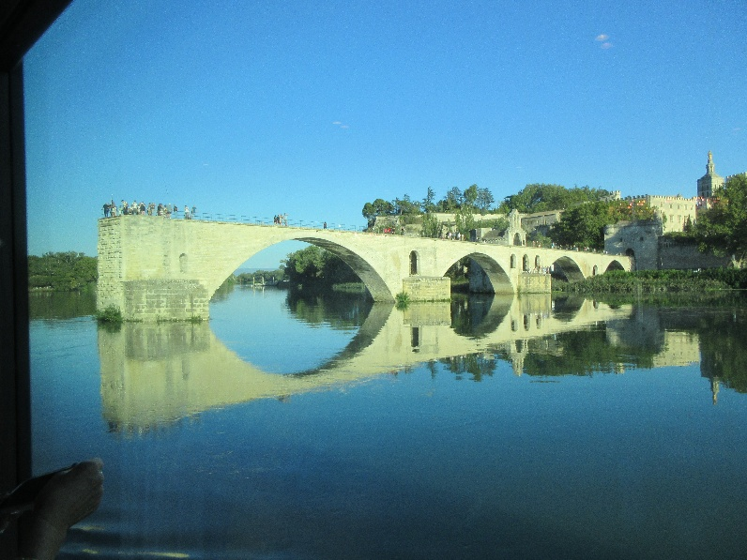
While we munched them, the ship cast off, and the captain sailed us upriver a little ways to get this great photo op of the Pont d'Avignon before reversing back to the turning basin and continuing downstream.

The climax of the day was the
"chef's signature dinner." Each course featured particular successes from the menus of other Tauck cruises.

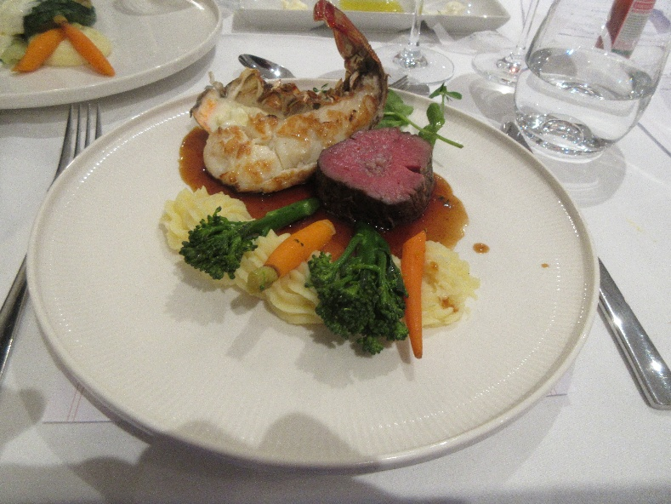
For example, the soup was Austrian cream of pumpkin with Styrian pumpkin seed oil, chives, and coconut foam, courtesy of the MS Joy on the Danube. I don't know whether Viking stole it from Tauck or the other way around, but it was a dead ringer for one we had on the Danube with Viking. Outstanding both times.

The surf-and-turf main course featured (farmed) Mediterranean spiny lobster and filet of beef!

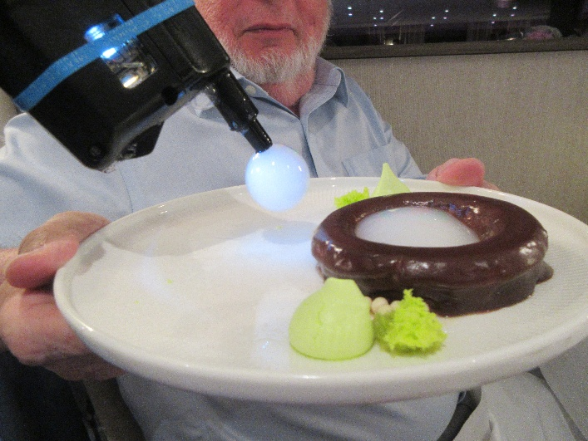
Dessert was a Hungarian chocolate cake ring with vanilla-flavored smoke! The pastry chef came around with a smoke gun, which she dipped the nozzle of into some sort of fluid that allowed her to extrude bubbles full of vanilla smoke, which she placed in the center of the ring and on the plate beside it. After a few seconds, they burst, releasing the vanilla smoke. Spectacular!

